**Molecular Dynamics Lab 2**

1. LAMMPS tutorial 3: stress-strain curve with labels for corresponding snapshot points below.

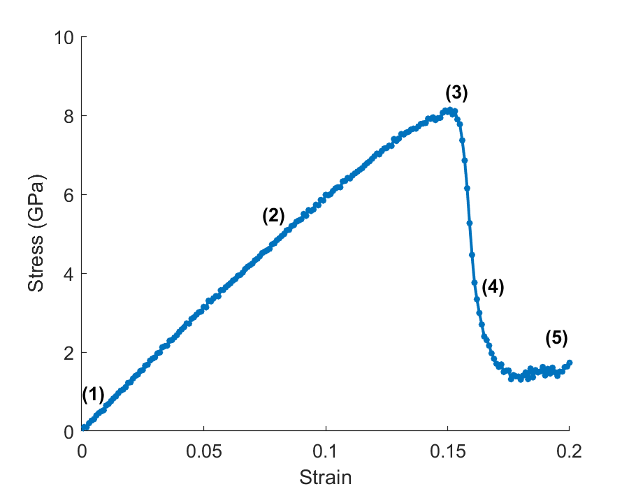

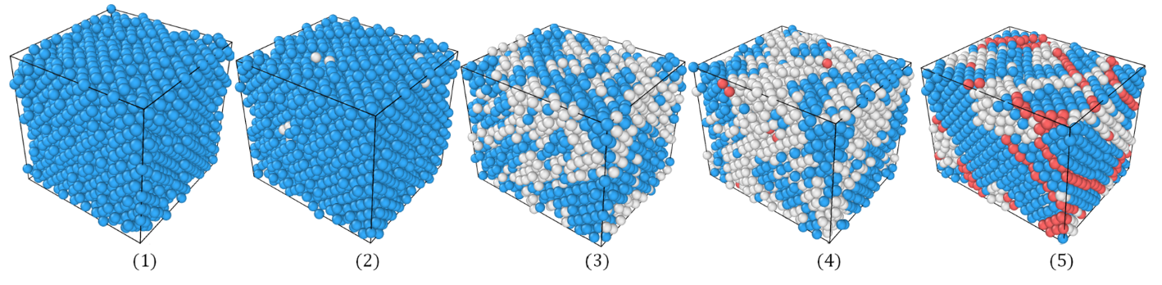

2. LAMMPS tutorial 5: calculate the grain boundary energy of a symmetric tilt grain boundary. Grain boundary energy was calculated: GB energy is 573.42 mJ/m2. Common neighbor analysis was used to show the change in the FCC lattice at the grain boundary. Below on the left is the initial overlap and the right shows the grain boundary after energy minimization.

3. Plotted below are the average total energy and standard deviation of the total energy versus simulation timestep. A timestep of 0.001 ps will be used for all further simulations.

4. To determine the system size the variance of the temperature versus 1 over the number of total atoms was plotted for several different starting temperatures. A system size of 864 atoms will be used which correspond to n = 6 (corresponds to the variance pointed out by the red arrow).

5. Below is a CNA analysis for the Xe lattice as the temperature increases. Blue represents the ordered lattice. As the temperature increases the lattice breaks apart which signifies melting. Melting occurs between 155 K and 165 K.

6. Plotted below is the caloric curve for Xe. From looking at the plot there is a discontinuity between 155 K and 160 K which means the melting temperature is somewhere between those two temperatures.

7i. Plots of the mean squared displacement (MSD) and diffusion coefficient calculated using the MSD.

7ii. The diffusion coefficient calculated using the velocity autocorrelation (VAF)

8. 4N3 is the number of atoms in an FCC unit cell with NxNxN unit cells.

9. If all atoms are considered then 4N3 force calculations are required at minimum, but it could be much more based on the dimensionality of the system. A cutoff would drastically reduce the number of force calculations. The distance between atoms should be calculated every time an atom moves.

10. LJ would require the least CPU time followed by, EAM, DFT, and HF. This is because LJ is a simple equation (pair potential), EAM is a pair functional (function of a function) , and DFT and HF both utilize quantum mechanics and therefore would take more CPU time than those that don’t.

11. Using the formula from part 8, that would result in about 250,000,000,000 (2.5 billion) unit cells. This would result in a supercell length of 31498 Å, or approximately 0.00315 mm

12. 1 particle has 8 nearest neighbors which means 16 floating point calculations per atom. The minimum number of particles for a single timestep to take 1 second would be 2.124 x 1015 particles.

13. The amount of time spent calculating distances could be faster by implementing a cutoff distance, and periodicity could also help lower distance calculations.